**INSERT-Console**

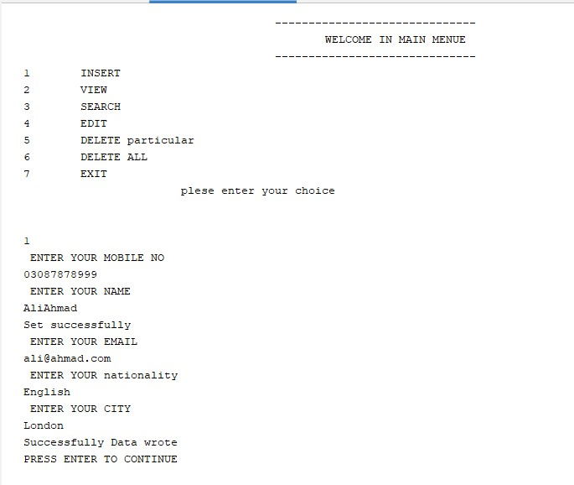

**Insert – TXT FILE**

**View – Console**

**Search – Console**

**Edit – Console**

**Edit – TXT**

**Delete – Particular -Console**

